This application note describes the Wi-Fi Connection Manager APIs available in the SDK, call-back events, notifications and the data structures associated with them. The accompanying sample codes help achieve some of these functionalities using WCM APIs.

# Topology

Figure 1: Wi-Fi Connection Manager – Topology

# Wi-Fi Connection Manager Functionalities

The Wi-Fi connection manager (WCM) contains functions for establishing and tearing down associations to Wi-Fi access points. It initiates a four-way handshake for encrypted connections and starts the DHCP client from LWIP for getting allocation of the IP address.

Following functionalities are achieved through these APIs:

* 1. Creating and destroying interfaces
  2. Scanning with different scan parameters and their indication structure
  3. Connecting and disconnecting
  4. Adding network to connect and removing network
  5. Querying connection information

Accompanying sample code provides more details on how to achieve some of the listed functionalities.

# List of APIs

1. os_get_boot_arg_str() - Returns the value of a boot argument as a null-terminated string.
2. xSemaphoreCreateCounting ()- Creates a semaphore. This API must be called before calling any other semaphore related APIs.
3. wcm_create()- Creates a Wi-Fi network interface. Only one wcm_handle instance is supported at the time of writing.
4. wifi_connect_to_network()- Adds a Wi-Fi network .
5. xSemaphoreTake ()- Locks a semaphore. If the value of the semaphore is greater than 0, it decrements the counter. If the value is 0, it puts the current thread to sleep until the value becomes positive. This function cannot be used in interrupt context.
6. os_msg_release()- Frees an allocated message. Frees a message previously allocated.
7. os_suspend_enable()- Enables system suspend when idle. Calling os_suspend_enable() will enable the suspend (deep sleep) for the system. If enabled, the system will go into suspend mode when there is nothing for the processor to do. Entering and leaving suspend mode takes some extra time, so enabling this will affect the real-time response of the system. When in suspended state, the system will still wakeup if an interrupt occurs, but the latency will be much larger compared to running with suspend mode disabled.
8. os_get_boot_arg_int()- Returns the value of a boot argument as an integer
9. wifi_init_scan_default()- Gets the default parameters for the scan operation. The wifi_scan_param will be updated with the default values for the scan operation. This function is used to get the default values and alter the parameters whose values are different from the default. Finally, provide these parameters while calling the wcm_scan() API.
10. wcm_scan()- Scans for Wi-Fi networks. Returns the number of networks found during the scan operation. In case the scan could not be performed, an error code (negative value) is returned. Initiate a network scan procedure on the specified Wi-Fi Connection Manager interface.
11. wifi_netinfo_get_ssid()-Gets the SSID information from netinfo.
12. wifi_netinfo_get_chan()-Gets the channel information from netinfo.
13. wcm_free_scanresult() - Frees the memory allocated by wcm_scan().
14. wcm_set_hostname() - Sets host name for DHCP client.
15. wcm_get_hostname() - Gets host name of DHCP client.

# States and Events of Wi-Fi Connection Manager

The architecture of the WCM, its calls and events with LWIP and Wi-Fi stacks are described in detail through the API flow.

WCM states are explained, and notifications passed to application programmer are described.

## Initialization

When the API wcm_create() is called, the following sequence of initializations happen on the WCM:

1. LWIP stack is initiated.
2. Wi-Fi interface and resources are created with the passed hwaddr.
3. Wi-Fi interface is created in WIFI_MODE_SCAN mode and a scan client is attached with scan_notify() and scan_done() call-backs to get scan results.
4. LWIP TCP/IP stack is started with the Wi-Fi interface in WIFI_MODE_STA mode.
5. wcm_notify_handler() is registered with the Wi-Fi stack for listening to the following link status notifications:

|  |
| --- |
| #define WIFI_NOTIFY_MSG_LEAVE 100 /* AP disconnected us */  #define WIFI_NOTIFY_MSG_LOST 101 /* Lost tracking of AP */  #define WIFI_NOTIFY_MSG_RESTARTED 102 /* Associated AP restarted */  #define WIFI_NOTIFY_MSG_REPLAY 103 /* sequence counter replay detected */  #define WIFI_NOTIFY_MSG_MICHAEL 104 /* Michael MIC failure detected */ |

1. wcm_netif_callback() is registered with LWIP stack for listening IP address change events.
2. A dedicated wcm_thread is created which takes care of WCM’s state transitions at various stages of Wi-Fi connection procedure based on the previously described call-backs from the Wi-Fi stack, scanning interface and LWIP stack.

## States of WCM

All the possible states of the WCM are defined as follows:

|  |
| --- |
| enum c_state {  C_DISCONNECTED = 0,  C_SCANNING = 1,  C_AUTHENTICATING = 2,  C_ASSOCIATING = 3,  C_WAIT_4WAY = 4,  C_CONNECTED = 5,  C_DISCONNECT_WAIT = 6,  C_TERMINATE = 7,  //[[[end]]]  }; |

The message pointer *msg has a message type associated with it. msg->msg_type can have a value from the enum wcm_notify_msg_type, containing message types of WCM. This will notify message callbacks as shown:

|  |
| --- |
| enum wcm_notify_msg_type {  /** WiFi link is up */  WCM_NOTIFY_MSG_LINK_UP = 200,  /** WiFi link is down */  WCM_NOTIFY_MSG_LINK_DOWN = 201,  /** Address has changed. The message sent is of type @ref wcm_address_event */  WCM_NOTIFY_MSG_ADDRESS = 202,  /** WiFi disconnect complete */  WCM_NOTIFY_MSG_DISCONNECT_DONE = 203,  /** WiFi connect complete */  WCM_NOTIFY_MSG_CONNECTED = 204,  /** WiFi deauthentication reason codes as provided by access point or by Talaria2 */  WCM_NOTIFY_MSG_DEAUTH_REASON_CODES = 205,  /** WiFi association status codes as provided by access point or by Talaria2 */  WCM_NOTIFY_MSG_ASSOC_STATUS_CODES = 206,  /** system error codes of type @ref system_notify_msg_code */  WCM_NOTIFY_MSG_SYSTEM_CODES = 207,  // [[[end]]]  }; |

If the notification WCM_NOTIFY_MSG_ADDRESS occurs, then the message received is of the type wcm_address_event. The structure definition for wcm_address_event is as follows:

|  |
| --- |
| struct wcm_address_event {  /** Message header */  struct os_msg iev_hdr;  /** Typically AF_INET or AF_INET6 */  unsigned int iev_af;  /** The address of up to 16 bytes (IPv6) */  unsigned char iev_address[0];  }; |

Address type and address data can be retrieved by typecasting the message to struct wcm_address_event.

# Source Code Walkthrough

## Wifi_Connect

### Overview

The sample code in the path *apps\using_wifi\src\wifi_connect.c* showcases simple connecting to a network with the API wifi_connect_to_network().

**Note:** Upon disconnection of station (Talaria TWO module) from the AP due to various reasons such as AP power off, module tries to reconnect by sending a probe request packet. Each failed connection attempt will increase the reconnect backoff time exponentially as 1, 2, 4, 8, 16, 32, 60 seconds.

After 60 seconds, module tries to reconnect indefinitely at every 60 seconds. Below sniffer capture shows Talaria TWO’s exponential reconnection method.

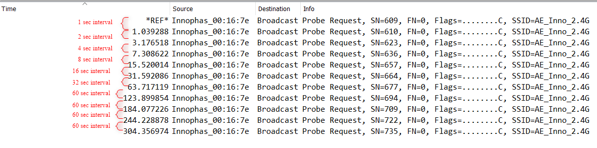

Figure 2: Sniffer Capture – Wi-Fi Reconnection

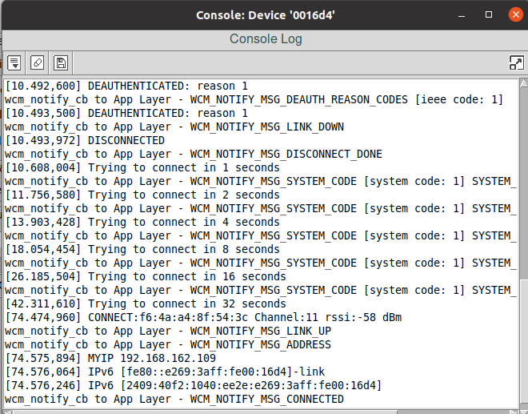

Figure 3: Talaria TWO Console Logs – Wi-Fi Reconnection

### Sample Code Walkthrough

To connect to a Wi-Fi network, wcm_create()API from the Wi-Fi Connection Manager is used. Initially, the Wi-Fi network interface is created using wcm_create().

|  |
| --- |
| h = wcm_create(NULL); |

wcm_set_hostname() API is used to set the host name in DHCP client. It is used for identifying the client device (Talaria TWO) in the network/AP.

Note: Default host name of Talaria TWO is talaria2.

|  |
| --- |
| if(host_name != NULL)  wcm_set_hostname(wcm_handle, host_name);  host_name = wcm_get_hostname(wcm_handle);  os_printf("host name %s\n", host_name); |

wifi_connect_to_network()API, from components library, connects to the Wi-Fi network using the AP credentials provided.

|  |
| --- |
| rval = wifi_connect_to_network(&h, WCM_CONN_WAIT_INFINITE, &wcm_connect_success);  if(rval < 0) {  os_printf("\nError: Unable to connect to network\n");  return 0;} |

### Running the Application

Program wifi_connect.elf(*freertos_sdk_x.y\examples\using_wifi\bin*)using the Download tool(*freertos_sdk_x.y\pc_tools\Download_Tool\bin*)provided with InnoPhase Talaria TWO SDK.

1. Launch the Download tool.
2. In the GUI window:
   1. Boot Target: Select the appropriate EVK from the drop-down.
   2. ELF Input: Load the wifi_connect.elf by clicking on Select ELF File.
   3. AP Options: Pass the appropriate SSID and passphrase to connect to an Access Point.
   4. Boot Arguments: Add the host name as a boot argument.

|  |
| --- |
| host_name=<host_name> |

Note: Default host name is talaria2.

* 1. Programming: Prog RAM or Prog Flash as per requirement.

### Expected Output

wifi_connect.elf execution displays the following output on the console for different scenarios:

|  |
| --- |
| UART:SNWWWWAE  4 DWT comparators, range 0x8000  Build $Id: git-ef87896f9 $  hio.baudrate=921600  flash: Gordon ready!  [7.750,092] partitions mounted  UART:SNWWWWAE  4 DWT comparators, range 0x8000  Build $Id: git-ef87896f9 $  hio.baudrate=921600  flash: Gordon ready!  Y-BOOT 208ef13 2019-07-22 12:26:54 -0500 790da1-b-7  ROM yoda-h0-rom-16-0-gd5a8e586  FLASH:PNWWWWWWAE  Build $Id: git-df9b9ef $  Flash detected. flash.hw.uuid: 39483937-3207-00b0-0064-ffffffffffff  Bootargs: host_name=InnoIot np_conf_path=/data/nprofile.json ssid=Lucy passphrase=Password@321  $App:git-6600fea  SDK Ver: FREERTOS_SDK_1.0  Wifi connect Demo App  addr e0:69:3a:00:16:d4  [0.592,108] CONNECT:c8:e7:d8:8c:ba:3c Channel:6 rssi:-64 dBm  [1.366,851] MYIP 192.168.1.105  [1.367,132] IPv6 [fe80::e269:3aff:fe00:16d4]-link  ------------- Connected to Network-------- |

## Wi-Fi Scan

### Overview

The sample code in the path *example\using_wifi\src\wifi_scan.c* scans for available Wi-Fi networks and prints them out.

Following are the steps:

1. Create a data structure to store the parameters and results of scan.
2. Set the default parameter for scanning using the API wifi_init_scan_default()
3. In a loop, let the code scan and print the nearby networks from vicinity for every 10 second interval of time.

### Sample Code Walkthrough

The necessary data structures to store parameters and result of scan are created as shown:

|  |
| --- |
| int main(void)  {  struct wcm_handle *h;  const size_t max_nets = 64;  struct wifi_netinfo **scan_result;  struct wifi_scan_param param;  …  …  …  scan_result = pvPortMalloc (max_nets * sizeof(void *));  assert(scan_result != NULL); |

wifi_init_scan_default()API is used to set the default parameters for the scanning, and wcm_scan() is used with explained parameters to start scanning.

The example code runs in a loop, scans and prints the results using wifi_netinfo_get_ssid() and wifi_netinfo_get_chan(), frees up the memory allocated for scan result using wcm_free_scanresult() and waits for 10 seconds before scanning and printing again as shown in the following code:

|  |
| --- |
| wifi_init_scan_default(&param);    // print scan parameters  print_scan_params(param);    for (;;) {  // perform scan  int n = wcm_scan(h, &param, scan_result, max_nets);  // print out results of scan  os_printf("Found %d nets:\n", n);  for (int i = 0; i < n; i++) {  uint8_t chan;  struct wifi_ssid ssid;  wifi_netinfo_get_ssid(scan_result[i], &ssid);  wifi_netinfo_get_chan(scan_result[i], &chan);  os_printf("%6pM on channel %2d @ %3d '%s'\n",  scan_result[i]->ni_bssid, chan,  scan_result[i]->ni_rssi, ssid.ws_ssid);  }  wcm_free_scanresult(scan_result, n);  vTaskDelay(1000);  } |

### Running the Application

Program wifi_scan.elf (*freertos_sdk_x.y\examples\using_wifi\bin*)using the Download tool provided with InnoPhase Talaria TWO SDK.

Refer steps mentioned in section 8.1.3 for more details.

### Expected Output

wifi_scan.elf execution displays the following output on the console for different scenarios:

|  |
| --- |
| UART:SNWWWWAE  4 DWT comparators, range 0x8000  Build $Id: git-ef87896f9 $  hio.baudrate=921600  flash: Gordon ready!  Y-BOOT 208ef13 2019-07-22 12:26:54 -0500 790da1-b-7  ROM yoda-h0-rom-16-0-gd5a8e586  FLASH:PNWWWWWAE  Build $Id: git-831e563 $  Flash detected. flash.hw.uuid: 39483937-3207-00b0-0064-ffffffffffff  $App:git-e608081  SDK Ver: FREERTOS_SDK_1.0  Wifi Scan Demo App  addr e0:69:3a:00:16:d4  Scan parameters:  channel_masks: 255 255 255 255 255 255 255 255  bssid: 0xFFFFFFFFFFFF  txrate: 0  waittime: 0  ie list: 0x  Found 5 nets:  f6:4a:a4:8f:54:3c on channel 11 @ -54 'Prasanna' 'WPA2-PSK'  6a:22:32:2c:80:6a on channel 1 @ -69 '' 'WPA2-PSK'  38:6b:1c:c0:da:38 on channel 13 @ -72 'connect_Idle_stability' 'WPA-PSK/WPA2-PSK Mixed Mode'  6a:22:32:60:06:52 on channel 1 @ -90 '' 'WPA2-PSK'  60:22:32:60:06:52 on channel 1 @ -92 'InnoIOT' 'WPA2-PSK'  Found 10 nets:  f6:4a:a4:8f:54:3c on channel 11 @ -52 'Prasanna' 'WPA2-PSK'  c8:7f:54:7b:bd:80 on channel 6 @ -56 'ASUS_WIFI_TB1' 'WPA2-PSK+MFPC'  bc:0f:9a:70:02:ef on channel 13 @ -58 'dlink_x1560wpa3' 'WPA2-PSK'  66:22:32:2c:80:6a on channel 1 @ -64 '' 'WPA2-PSK'  60:22:32:2c:80:6a on channel 1 @ -65 'InnoIOT' 'WPA2-PSK'  6a:22:32:2c:80:6a on channel 1 @ -69 '' 'WPA2-PSK'  38:6b:1c:c0:da:38 on channel 13 @ -70 'connect_Idle_stability' 'WPA-PSK/WPA2-PSK Mixed Mode'  12:27:f5:6d:e8:74 on channel 9 @ -80 '' 'WPA2-PSK'  10:27:f5:7d:e8:74 on channel 9 @ -80 'tplinkc6_iop' 'WPA2-PSK'  5c:f9:fd:7c:2f:79 on channel 10 @ -94 'Airtel_Zerotouch' 'WPA-PSK/WPA2-PSK Mixed Mode' |

### Power Optimization with Rx Nap Scan

In a crowded environment, Rx Nap Scan feature can be enabled to save power during the scan process. In this mode, the Rx nap function will turn the Talaria TWO’s receiver OFF (*takes a nap*) for the duration of the frame when there are uninteresting frames with high signal strength. The frames of interest are probe responses and beacon frames.

This mode is enabled by default in wifi_scan.elf and can be disabled using the following boot argument:

|  |
| --- |
| wifi.nap_scan=0 |

As shown in Figure 4, Talaria TWO takes naps when there are uninteresting frames. During the naps, current consumption dips to 8mA whereas during the scan period, the average Rx current remains at ~33mA.

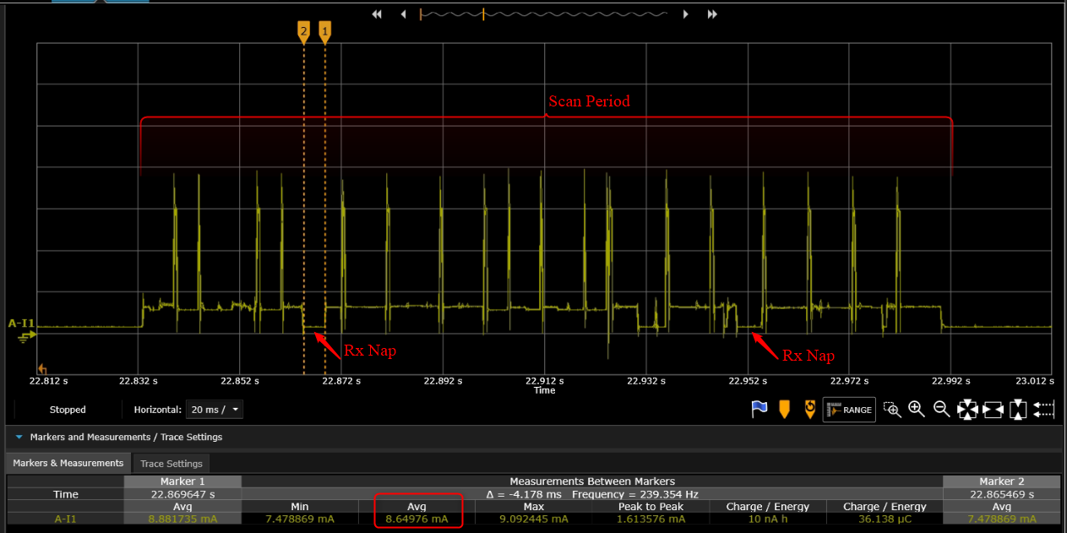

Figure 4: Talaria TWO naps during uninteresting frames

Rx nap scan mode disabled is as shown in Figure 5.

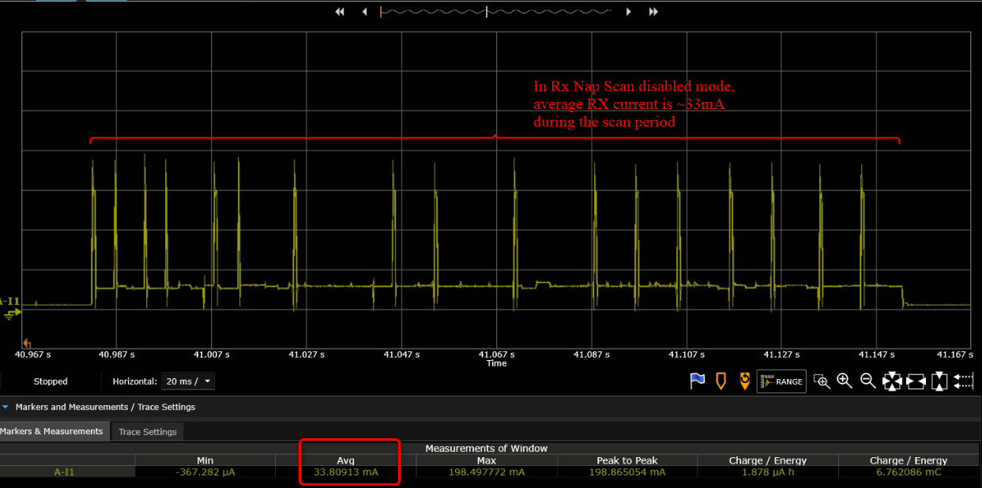

Figure 5: Rx nap scan mode disabled

## Wifi_Connect_Disconnect

### Overview

The sample code in the path: *apps\using_wifi\src\wifi_connect_disconnect.c* showcases connecting to and disconnecting from a network asynchronously with the API wcm_auto_connect() and wcm_add_network_profile().

### Sample Code Walkthrough

This example code initializes two semaphores and creates two tasks.

|  |
| --- |
| /* initializes the semaphores */  my_sem1 = xSemaphoreCreateCounting(1, 0);  my_sem2 = xSemaphoreCreateCounting(1, 0);  /* creates a task */  xTaskCreate(my_app_task_func1, "task1", MY_APP_THREAD_STACK_SIZE,  (void *)my_arg1, MY_APP_THREAD_PRIO, &task1);  /* creates a task */  xTaskCreate(my_app_task_func2, "task2", MY_APP_THREAD_STACK_SIZE,  (void *)my_arg2, MY_APP_THREAD_PRIO, &task2);  vTaskSuspend(NULL);  return 0; |

On executing, task2 enters a loop where it first waits for a semaphore from task1.

task 1 on running, attempts wcm_add_network_profile()and wcm_auto_connect()with param bool enable as 1 to connect, and waits for 10 seconds and finally enters a loop where it performs the following:

1. Calls wcm_auto_connect()with param bool enable as 0 to asynchronously disconnect, without removing the network
2. Waits for 10 seconds and unblocks task2 by posting a semaphore
3. Finally waits on a semaphore posted from task2, before looping back again to asynchronously disconnect attempt using wcm_auto_connect()

|  |
| --- |
| /* the Task function */  static void  my_app_task_func1(void *arg)  {  os_printf("task1 prints -- %s\n", (char *)arg);  /* Create a Wi-Fi network interface */  my_wcm_handle = wcm_create(NULL);  wcm_notify_enable(my_wcm_handle, my_wcm_notify_cb, NULL);  /*"/data/nprofile.json" */  const char *np_conf_path = os_get_boot_arg_str("np_conf_path") ?: NULL;  struct network_profile *profile;  int rval;  if (np_conf_path != NULL) {  /* Create a Network Profile from a configuration file in  *the file system */  rval = network_profile_new_from_file_system(&profile, np_conf_path);  } else {  /* Create a Network Profile using BOOT ARGS */  rval = network_profile_new_from_boot_args(&profile);  }  if (rval < 0) {  pr_err("could not create network profile %d\n", rval);  return;  }  rval = wcm_add_network_profile(my_wcm_handle, profile);  if (rval < 0) {  pr_err("could not associate network profile to wcm %d\n", rval);  return;  }  vTaskDelay(2000);  os_printf("task1 prints -- calling api wcm_auto_connect(1) to connect to "  "already added network\n");  wcm_auto_connect(my_wcm_handle, 1);  os_printf("task1 prints -- will try a disconnect after 10 seconds... \n");  vTaskDelay(10000);  while (1) {  os_printf("task1 prints -- calling api wcm_auto_connect(0) to just "  "disconnect without removing network..\n");  wcm_auto_connect(my_wcm_handle, 0);  vTaskDelay(10000);  /* unlock Thread2 */  xSemaphoreGive(my_sem2);  /* block until task 2 unblocks us */  xSemaphoreTake(my_sem1, portMAX_DELAY);  }  } |

As noted earlier, task2 is in a loop, and when unblocked:

1. Calls wcm_auto_connect()with param bool enable as 1 to asynchronously connect to previously added network
2. Waits for 10 seconds and unblocks task1 by posting a semaphore
3. Enters the loop again where it finally waits on a semaphore posted from task1, before trying to asynchronously connect using wcm_auto_connect().

|  |
| --- |
| /* the task function */  static void  my_app_task_func2(void *arg)  { vTaskDelay(5000);  os_printf("task2 prints -- %s\n", (char *)arg);  while (1) {  /* block until task 1 unblocks us */  xSemaphoreTake(my_sem2, portMAX_DELAY);  os_printf("task2 prints -- calling api wcm_auto_connect(1) to connect "  "to already added network\n");  wcm_auto_connect(my_wcm_handle, 1);  vTaskDelay(10000);  /* unlock Thread1 */  xSemaphoreGive(my_sem1);  }  } |

In this example, Talaria TWO module connects and disconnects from the network approximately every 10 seconds without removing the network name.

Notifications from WCM are registered and are printed similar to the previous example.

### Running the Application

Program wifi_connect_diconnect.elf (*sdk_x.y\examples\using_wifi\bin*) using the Download Tool provided with InnoPhase Talaria TWO SDK.

Refer steps mentioned in section 8.1.3 for more details.

### PMK Caching

When Talaria TWO connects to an Access Point, the PMK generated after 802.1X authentication method will be stored in Talaria TWO’s flash and this cached PMK will be used for subsequent connections.

This ensures minimal connection latency between the Access Point and Talaria TWO as it avoids recomputing of PMK for each connection. PMK cache feature is supported only on WPA2-PSK or Mixed mode.

### Expected Output

wifi_connect_disconnect.elf execution displays the following output on the console for different scenarios:

#### Case 1

AP is already ON at connection attempt, connect success, alternate connect disconnect with autoconnect API, add and remove network, as expected.

Background notifications are received.

|  |
| --- |
| Y-BOOT 208ef13 2019-07-22 12:26:54 -0500 790da1-b-7  ROM yoda-h0-rom-16-0-gd5a8e586  FLASH:PWWWWWWAE  Build $Id: git-831e563 $  Flash detected. flash.hw.uuid: 39483937-3207-0061-00a2-ffffffffffff  Bootargs: ssid=test passphrase=12345678  SDK Ver: FREERTOS_SDK_1.0  Wifi Async Connect Demo App  task1 prints -- application task1 will attempt wcm_add_network_profile() and wcm_auto_connect(1) and then disconnect with wcm_auto_connect(0) 10 seconds after every connection  addr e0:69:3a:00:15:a8  network profile created for ssid: test  task1 prints -- calling api wcm_auto_connect(1) to connect to already added network  task1 prints -- will try a disconnect after 10 seconds...  [4.802,027] DISCONNECTED  [4.960,984] CONNECT:8e:44:eb:4a:ff:f2 Channel:6 rssi:-49 dBm  wcm_notify_cb to App Layer - WCM_NOTIFY_MSG_LINK_UP  task2 prints -- application task2 will attempt connect using wcm_auto_connect(1).  wcm_notify_cb to App Layer - WCM_NOTIFY_MSG_ADDRESS  [5.066,941] MYIP 192.168.122.64  [5.067,105] IPv6 [fe80::e269:3aff:fe00:15a8]-link  task1 prints -- calling api wcm_auto_connect(0) to just disconnect without removing network..  wcm_notify_cb to App Layer - WCM_NOTIFY_MSG_LINK_DOWN  [12.059,776] DISCONNECTED  task2 prints -- calling api wcm_auto_connect(1) to connect to already added network  [22.360,925] CONNECT:8e:44:eb:4a:ff:f2 Channel:6 rssi:-53 dBm  wcm_notify_cb to App Layer - WCM_NOTIFY_MSG_LINK_UP  wcm_notify_cb to App Layer - WCM_NOTIFY_MSG_ADDRESS  [22.440,115] MYIP 192.168.122.64  [22.440,165] IPv6 [fe80::e269:3aff:fe00:15a8]-link  [22.440,230] IPv6 [2409:40c1:102f:5e67:e269:3aff:fe00:15a8]  task1 prints -- calling api wcm_auto_connect(0) to just disconnect without removing network..  wcm_notify_cb to App Layer - WCM_NOTIFY_MSG_LINK_DOWN  [32.063,542] DISCONNECTED |

#### Case 2

AP is already ON at connection attempt, wrong password provided, connect failure, alternate connect disconnect and add network and remove network as expected, without any task hanging.

|  |
| --- |
| Y-BOOT 208ef13 2019-07-22 12:26:54 -0500 790da1-b-7  ROM yoda-h0-rom-16-0-gd5a8e586  FLASH:PWWWWWWAE  Build $Id: git-831e563 $  Flash detected. flash.hw.uuid: 39483937-3207-0061-00a2-ffffffffffff  Bootargs: ssid=test passphrase=123456789  SDK Ver: FREERTOS_SDK_1.0  Wifi Async Connect Demo App  task1 prints -- application task1 will attempt wcm_add_network_profile() and wcm_auto_connect(1) and then disconnect with wcm_auto_connect(0) 10 seconds after every connection  addr e0:69:3a:00:15:a8  network profile created for ssid: test  task1 prints -- calling api wcm_auto_connect(1) to connect to already added network  task1 prints -- will try a disconnect after 10 seconds...  [2.864,106] CONNECT:da:14:ac:e6:b5:f1 Channel:6 rssi:-51 dBm  task2 prints -- application task2 will attempt connect using wcm_auto_connect(1).  [6.878,443] DEAUTHENTICATED: reason 15  [6.879,737] DISCONNECTED during key negotiation, wrong key?  [6.951,227] Trying to connect in 2 seconds  [9.200,373] CONNECT:da:14:ac:e6:b5:f1 Channel:6 rssi:-50 dBm  task1 prints -- calling api wcm_auto_connect(0) to just disconnect without removing network..  [12.059,689] DISCONNECTED during key negotiation, wrong key?  task2 prints -- calling api wcm_auto_connect(1) to connect to already added network  [22.281,520] CONNECT:da:14:ac:e6:b5:f1 Channel:6 rssi:-57 dBm  [26.306,590] DEAUTHENTICATED: reason 15  [26.307,313] DISCONNECTED during key negotiation, wrong key?  [26.378,251] Trying to connect in 2 seconds  [28.603,887] CONNECT:da:14:ac:e6:b5:f1 Channel:6 rssi:-51 dBm  task1 prints -- calling api wcm_auto_connect(0) to just disconnect without removing network..  [32.061,392] DISCONNECTED during key negotiation, wrong key?  task2 prints -- calling api wcm_auto_connect(1) to connect to already added network  [42.343,717] CONNECT:da:14:ac:e6:b5:f1 Channel:6 rssi:-50 dBm  [50.343,866] DISCONNECTED during key negotiation, wrong key?  [50.419,134] Trying to connect in 2 seconds  task1 prints -- calling api wcm_auto_connect(0) to just disconnect without removing network..  task2 prints -- calling api wcm_auto_connect(1) to connect to already added network  [62.319,817] CONNECT:da:14:ac:e6:b5:f1 Channel:6 rssi:-50 dBm  [70.320,202] DISCONNECTED during key negotiation, wrong key?  [70.391,726] Trying to connect in 2 seconds  task1 prints -- calling api wcm_auto_connect(0) to just disconnect without removing network.. |

#### Case 3

AP is switched OFF at connection attempt, alternate connect disconnected and remove network as expected, without any task hanging.

Later, AP is switched ON, connect success, alternate connect disconnect and add remove as expected.

|  |
| --- |
| Y-BOOT 208ef13 2019-07-22 12:26:54 -0500 790da1-b-7  ROM yoda-h0-rom-16-0-gd5a8e586  FLASH:PWWWWWWAE  Build $Id: git-831e563 $  Flash detected. flash.hw.uuid: 39483937-3207-0061-00a2-ffffffffffff  Bootargs: ssid=test passphrase=12345678  SDK Ver: FREERTOS_SDK_1.0  Wifi Async Connect Demo App  task1 prints -- application task1 will attempt wcm_add_network_profile() and wcm_auto_connect(1) and then disconnect with wcm_auto_connect(0) 10 seconds after every connection  addr e0:69:3a:00:15:a8  network profile created for ssid: test  task1 prints -- calling api wcm_auto_connect(1) to connect to already added network  task1 prints -- will try a disconnect after 10 seconds...  [2.820,409] CONNECT:56:81:d3:91:b1:08 Channel:6 rssi:-36 dBm  wcm_notify_cb to App Layer - WCM_NOTIFY_MSG_LINK_UP  wcm_notify_cb to App Layer - WCM_NOTIFY_MSG_ADDRESS  [2.885,129] MYIP 192.168.122.64  [2.885,293] IPv6 [fe80::e269:3aff:fe00:15a8]-link  task2 prints -- application task2 will attempt connect using wcm_auto_connect(1).  task1 prints -- calling api wcm_auto_connect(0) to just disconnect without removing network..  wcm_notify_cb to App Layer - WCM_NOTIFY_MSG_LINK_DOWN  [12.059,726] DISCONNECTED  task2 prints -- calling api wcm_auto_connect(1) to connect to already added network  [22.571,246] Trying to connect in 1 seconds  [23.726,939] Trying to connect in 2 seconds  [25.930,213] Trying to connect in 4 seconds  [30.085,341] Trying to connect in 8 seconds  task1 prints -- calling api wcm_auto_connect(0) to just disconnect without removing network..  task2 prints -- calling api wcm_auto_connect(1) to connect to already added network  [42.700,208] Trying to connect in 1 seconds  [43.877,703] Trying to connect in 2 seconds  [46.038,532] Trying to connect in 4 seconds  [50.201,438] Trying to connect in 8 seconds  task1 prints -- calling api wcm_auto_connect(0) to just disconnect without removing network..  task2 prints -- calling api wcm_auto_connect(1) to connect to already added network  [62.622,375] CONNECT:da:14:ac:e6:b5:f1 Channel:6 rssi:-42 dBm  wcm_notify_cb to App Layer - WCM_NOTIFY_MSG_LINK_UP  wcm_notify_cb to App Layer - WCM_NOTIFY_MSG_ADDRESS  [62.689,656] MYIP 192.168.122.64  [62.689,820] IPv6 [fe80::e269:3aff:fe00:15a8]-link  [62.689,885] IPv6 [2409:40c1:102f:5e67:e269:3aff:fe00:15a8]  task1 prints -- calling api wcm_auto_connect(0) to just disconnect without removing network..  wcm_notify_cb to App Layer - WCM_NOTIFY_MSG_LINK_DOWN  [72.065,233] DISCONNECTED |